Kosuke Takahashi

CS370 Homework 3

6-8

1. 8
2. 3
3. 4

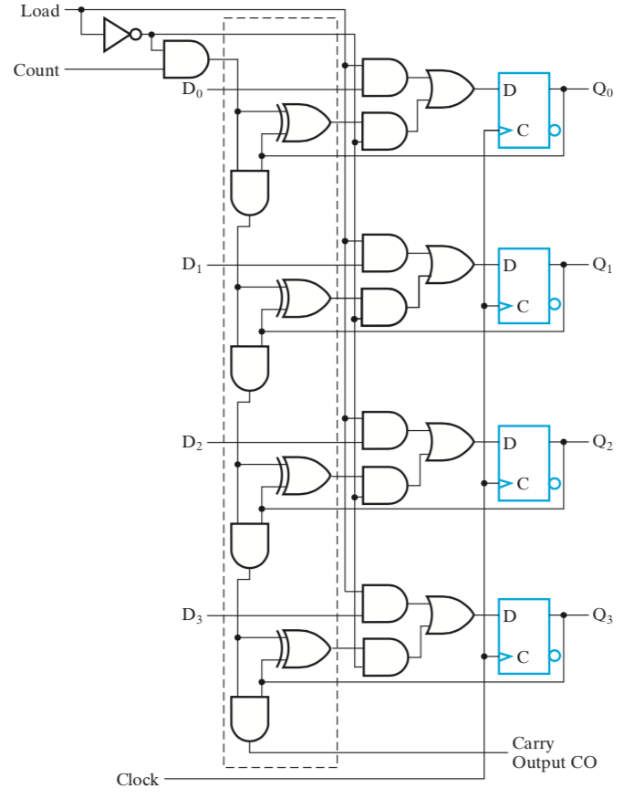6-12

7-3

1. Bits in an array = 216 \* 24 = 220

Size = 210 (because RAM cell array is square)

Row Decoder is 10 to 1024 🡪 210

Column Decoder is 6 to 64 or 216 – 210 🡪 26

AND gates = 210 + 26 = 1024 + 64 = 1088

1. (32000)10 = (011111010000000)2

0111110100 00000 🡪 500 Rows and 0 Columns

8-5

7-9